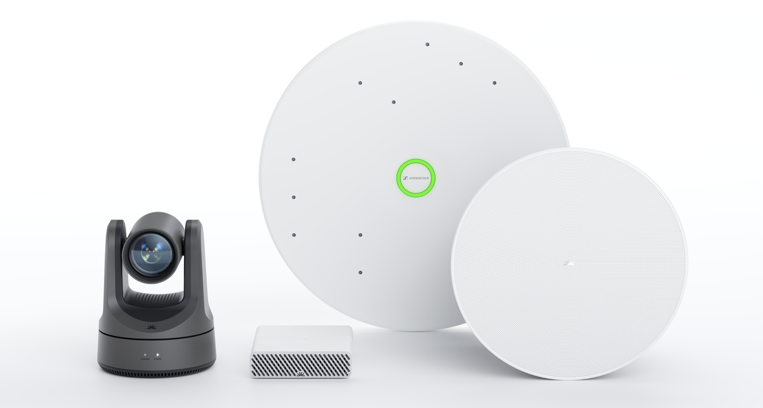
Pleneo and Sennheiser Announce Intelligent Room Kits for Scalable Medium and Large Meeting Spaces

Barcelona, Spain 3 February 2026 — Pleneo and Sennheiser today announced the availability of two intelligent meeting room kits designed to remove installation complexity, reduce deployment cost, and enable consistent, AI-ready collaboration experiences in medium and large meeting spaces at scale.

High-quality, intelligible audio is foundational to modern, AI-powered meetings — particularly in large, organisation-critical spaces. As enterprises increasingly rely on intelligent meeting workflows such as speaker recognition, voice attribution, transcription, and meeting analysis, the accuracy of those experiences depends on clear, consistent audio capture across the entire room. In larger spaces, where multiple participants speak, move, and present, achieving that consistency has traditionally required complex design and tuning.

The Pleneo Medium Room Kit and Pleneo Large Room Kit are designed to change that. Engineered for rooms up to 50 m² (approx. 10 m × 5 m) and 90 m² (approx. 12 m × 7.5 m) respectively, the kits extend AI-enabled collaboration into larger environments that are typically difficult to standardise and scale. By integrating Sennheiser TeamConnect Ceiling Medium (TCC M) microphones as part of a fully orchestrated Pleneo system, the kits deliver high-performance audio pickup that supports intelligent meeting experiences in the spaces where collaboration matters most.

Each kit is built around Pleneo RoomHub, which connects all room endpoints into Pleneo Room OS — the system layer that powers the room as a single, unified environment. Room OS enables zero-touch deployment and automated setup, allowing complete rooms to be brought online without specialist configuration or individual tuning of audio or video settings. Rooms deploy over standard IT infrastructure, using enterprise-grade security and governance frameworks by design.

RoomHub applies AI-driven audio tuning and enhancement across the system, including adaptive room tuning, AI NoiseSense, ML-based room enhancement, and IQ Voice Enhancement, to ensure clear, consistent speech regardless of room acoustics or participant behaviour. The result is reliable, highly intelligible audio that supports both human collaboration and AI-driven meeting intelligence.

Video intelligence is delivered through Pleneo RoomVision cameras, which support AI speaker tracking that automatically follows the active presenter, as well as AI autoframing that keeps participants naturally framed without distracting camera movement. The inclusion of Sennheiser’s TCC M provides premium audio quality combined with automatic dynamic beamforming technology to capture voices from every corner of the room. Together, the audio and video systems behave as part of a coordinated whole, rather than independent devices.

Using Pleneo Cloud, rooms are provisioned, configured, monitored, and managed centrally as complete systems. IT teams can manage rooms directly within Pleneo Cloud or integrate room data and events into the platforms they already use for IT service management and operations, enabling consistent oversight without introducing new operational silos.

“These room kits are about transforming how large meeting spaces are delivered at scale,” said James Knight, CEO, Pleneo. “As meetings become more intelligent and more reliant on AI-driven workflows, capturing clear, accurate voices across large rooms is essential. Pleneo Room OS makes that possible by removing the need for individual configuration and manual tuning, and by turning complex systems into predictable, software-driven spaces that are easy to deploy, manage, and trust.”

“Clear, reliable audio is critical for effective collaboration, especially in larger rooms,” said Charlie Jones, Sr. Partner Relations Manager, Sennheiser. “These kits brings the audio quality large rooms need for intelligent meetings into a form IT can deploy, scale, and support, ensuring intelligent meetings receive the high-quality audio inputs they need to perform at their best from group collaboration.”

The Pleneo x Sennheiser Room Kits are available through joint distribution partners in the Americas, Europe, Middle East & India, and Asia-Pacific regions, supporting multi-country deployments for enterprise, corporate, and education customers.

Learn more at www.pleneo.com/sennheiser

Pleneo Intelligent Room Kits
Pleneo offers two curated, complete room kits, allowing customers to easily select a system based on room size while maintaining a consistent experience across locations.
Pleneo x Sennheiser Medium Room Kit
For rooms up to 50 m² (approx. 10 m × 5 m)
- Pleneo RoomHub
- Pleneo RoomVision camera
- (1) Sennheiser TeamConnect Ceiling Medium microphone
- (4) Pleneo RoomDesign Ceiling PoE speakers
- Complete cabling set
- Fully deployed and managed via Pleneo Room OS and Pleneo Cloud

Pleneo x Sennheiser Large Room Kit (available soon)
For rooms up to 90 m² (approx. 12 m × 7.5 m)
- Pleneo RoomHub
- Pleneo RoomVision XL camera
- (2) Sennheiser TeamConnect Ceiling Medium microphones
- (6) Pleneo RoomDesign Ceiling PoE speakers
- Complete cabling set
- Fully deployed and managed via Pleneo Room OS and Pleneo Cloud

[Ends]

About Pleneo®

Pleneo creates intelligent technologies for the spaces where people meet. Across the Room OS platform, Pleneo unifies audio, video, and data into one adaptive hardware + software ecosystem—powered by AI, designed for simplicity, and secured for enterprise scale.
Driven by the belief that great collaboration should feel effortless, Pleneo builds systems that deploy in minutes, configure themselves for the room, and continuously adapt using real data across connected devices. Every product reflects Pleneo’s commitment to design, performance, and trust—delivering a new standard in collaboration technology for organizations.

Pleneo. Big Rooms, Made Easy.

About the Sennheiser Group

Building the future of audio and creating unique sound experiences for our customers - this is the aspiration that unites the employees of the Sennheiser Group worldwide. The independent, family-owned company Sennheiser was founded in 1945. Today, it is managed in the third generation by Dr. Andreas Sennheiser and is one of the leading manufacturers in the field of professional audio technology.

sennheiser.com | neumann.com | merging.com

Global Sennheiser Press Contact
Jeffrey Horan
Global PR/Media Manager Business Communication
jeffrey.horan@sennheiser.com
+1 860-598-7539

